**Class Activity**

# Effect of changing font on the system

**Independent Variable:** Font.

**Dependent:**

1. Consistency in the system.

**Hypothesis**: Changing the font doesn’t have much effect on the system, yet it still disrupts the consistency in the system. Having different fonts in different windows will lead to poor user interaction as the system won’t be consistent.

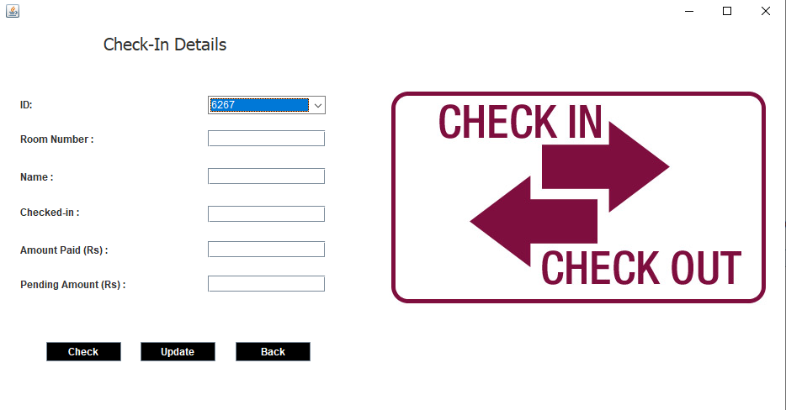

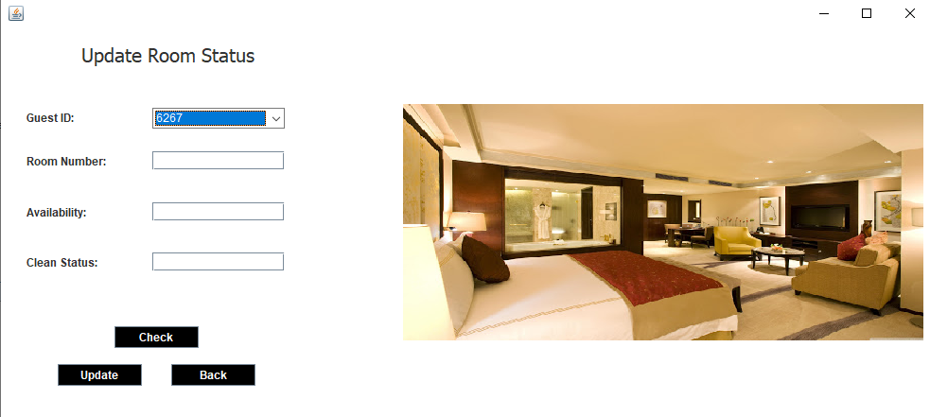

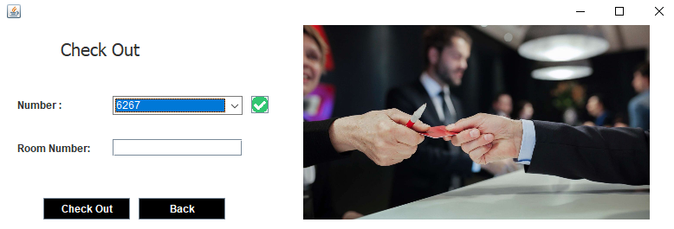

# Effect of adding a customer to the system

**Independent Variable:** Customer.

**Dependent Variable:**

1. **Rooms info**

**Hypothesis:** The availability status of the room booked by the customer is changed from “available” to “occupied.”

1. **Customer Info**

**Hypothesis**: A new row is added to the table consisting of customer information. The new row contains the information of newly added customer.

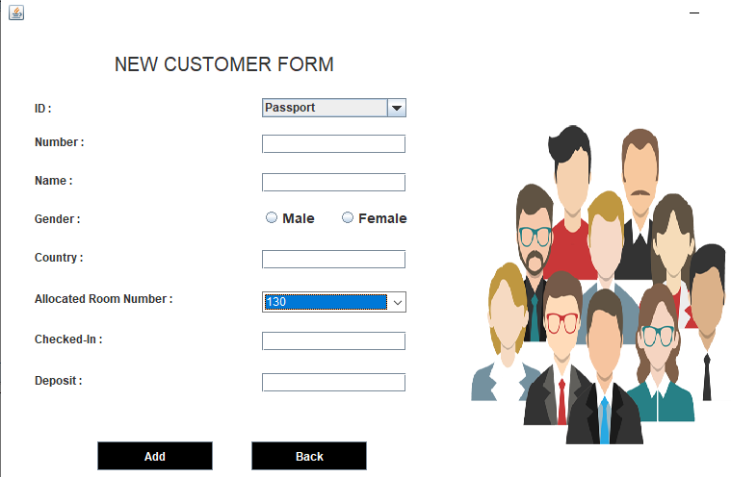



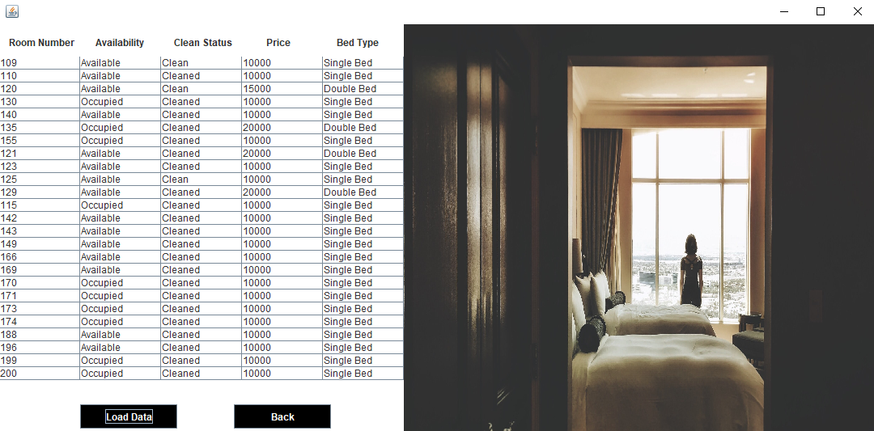

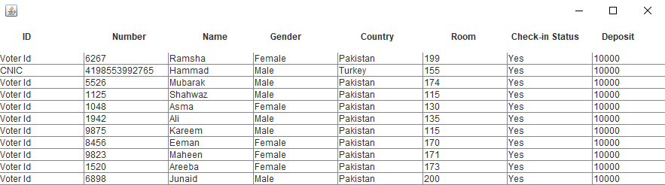

# Effect of customer checking out from the hotel

**Independent Variable:** Customer checking out.

**Dependent Variable:**

1. **Rooms info**

**Hypothesis:** When the customer checks out from the room, the availability of the room changes from “occupied.” to “available.”

1. **Customer Info**

**Hypothesis:** A row consisting of customer’s information is deleted from the table.





# Effect of changing font size on the system usability

**Independent Variable:** Font Size.

**Dependent:**

1. Table Alignment.

**Hypothesis**: It ensures customer’s satisfaction as it improves readability and usability.

 For example: The table’s alignment can turn out to be clustered if the font size is not consistent with it. Therefore, for easy interaction font size plays a vital role.

1. Size of buttons, with labels.

**Hypothesis**: It has an effect on the visibility as if font size precedes the space of the label, it will negatively affect the presentation.

1. Overall visibility of the system.

**Hypothesis**: The efficient visibility is surely maintained by a compatible font size.

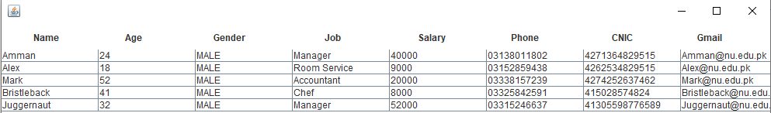

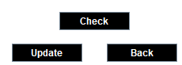

# Using Positive contrast over negative contrast

**Independent Variable:** Contrast.

**Dependent:**

1. User Satisfaction

**Hypothesis:** The interaction between the customer and system can be inappropriate if the interface is complicated to understand.

1. Readability Issues

**Hypothesis**: The positive contrast makes the layout hard to get and could be misleading whereas the color scheme of negative contrast increases the system’s visibility.

